UNIT6: THE YOUNG PIONEERS CLUB
GETTING STARTED (Học sinh tự thực hiện)
Task 1: Identify the activities that Ho Chi Mirth Young Pioneer and Organization (Y&Y) participate in. Check (✓) the boxes, then add activities to the list.
(Em hãy xác nhận những hoạt động mà Đoàn Thanh niên và Tình nguyện thành phố Hồ Chí Minh (Y&Y) tham gia. Hãy đánh dấu (✓ ) vào ô rôi thêm vào danh sách một số hoạt động nữa.)
helping blind people □
helping elderly people □
helping handicapped children □
cleaning up beaches □
caring for animals □
taking part in sports □
suggested answers:
✓ helping blind people
✓ helping elderly people
✓ helping handicapped children
✓ taking part in sports
✓ cleaning up beaches
✓ planting green trees
✓ cleaning up streets, river banks and lakes
Vocabulary:
- blind /blaɪnd/ (adj): bị mù -> blind people: người mù
- elderly /ˈel.dɚ.li/ (adj): lớn tuổi, cao tuổi -> elderly people: người già, người cao tuổi
- handicapped /ˈhæn.dɪ.kæpt/ (adj): bị tật nguyền, bị tàn tật
- care for /ker/ (v) = take care of = look after (v): chăm sóc, chăm nom
LISTEN AND READ
Secretary: Hello. May I help you?
Nga: Good morning. I’m enrolling for the activities for this summer.
Secretary: Right. Let me get an application form and we can fill it out. What's your full name, please?
Nga: Pham Mai Nga.
Secretary: And when were you born?
Nga: April 22, 1989.
Secretary: Where do you live and do you have a phone number?
Nga: I live at 5 Tran Phu Street, and I don’t have a phone at home.
Secretary: Now, what are your hobbies?
Nga: I like drawing and outdoor activities. And I enjoy acting, too.
Secretary: Drawing, outdoor activities,... and acting.
Well, please take this form to your teacher and ask her to sign it. Then bring the form back to me.
Nga: All right. Thank you.
VOCABULARY:
- enroll /ɪnˈrəʊl/ (v): đăng ký, ghi danh
- application form: mẫu đơn (có sẵn để điền vào)
- fill out (v) = fill in (v): điền vào (mẫu đơn)
- hobby /ˈhɑː.bi/ (n): sở thích
- sign /saɪn/ (v): ký tên – signature /ˈsɪɡ.nə.tʃɚ/ (n): chữ ký
- take s.th to s.b: đưa cái gì cho ai
- bring s.th back to s.b: đưa trả lại cái gì cho ai
- sex /seks/ (n): giới tính
- male /meɪl/ (n): nam
- female /ˈfiː.meɪl/ (n): nữ
Task 1. Practice the dialogue with a partner.
(Em hãy thực hành hội thoại với bạn em.)

Task 2. Complete Nga’s details.
(Hãy hoàn thành các chi tiết về Nga.)
• Name: | • Date of birth:
• Home address: | • Sex:
• Phone number: | • Interests:

Suggested answer:
Name: | Pham Mai Nga
Date of birth: | April 22, 2004
Sex: | Female
Home address: | 5 Tran Phu
Phone number: | Not available
Interests: | drawing, outdoor activities and acting

SPEAK (Học sinh tự học)
Look at the phrases in the boxes. Then practice the dialogues with a partner.
(Hãy xem các cụm từ cho trong khung rồi luyện hội thoại với bạn em.)
Asking for favors | Responding to favors
Can/Could you help me, please?  Could you do me a favor?  I need a favor.  Can/Could you...? | Certainly/ Of course/ Sure.  No problem.  What can I do for you?  How can I help you?  I'm sorry. I'm really busy.
Offering assistance | Responding to assistance
May I help you?  Do you need any help?  Let me help you. | Yes/No. Thank you.  Yes. That’s very kind of you.  No. Thank you. I’m fine.
a.
Mrs. Ngoc: Could you do me a favor, please?
Hoa: Sure. What can I do for you?
Mrs. Ngoc: Can you help me carry my bags? I’ve hurt my arm.
Hoa: Certainly. I’ll help you.
Mrs. Ngoc: Thank you very much. That’s very kind of you.
b.
Receptionist: May I help you?
Tourist: Yes. Can you show me the way to the nearest bank?
Receptionist: Sure. Turn right when you get out of the hotel.
Turn left at the first corner. It’s on your right.
Tourist: Thank you very much.

Now use the appropriate phrases in the box to make similar dialogues about some of the following situations with a partner.
(Bây giờ em hãy sử dụng các cụm từ thích hợp trong khung để làm những hội thoại tương tự về một vài tình huống sau đây với bạn em.)
Suggested answer:
1.
Tourist: Could you do me a favor?
You: Sure. What can I do for you?
Tourist: I lost my money. Could you show me the way to the nearest police station?
You: Certainly. Turn right out of the station. Turn right again at the first corner. Go straight ahead until you see the police station on your right.
Tourist: Thank you very much.
You: You’re welcome.
2.
You: May I help you?
Neighbor: Yes. My leg broke. Can you help me to tidy the yard, please?
You: Of course. Now, let me help you.
Neighbor: Thank you. That's very kind of you.
3.
Your friend: Can you help me, please?
You: How can I help you?
Your friend: My bike has a flat tire. Can you help me to fix it?
You: Certainly. I’ll help you.
Your friend: Thanks a lot.
4.
You: Do you need any help?
Your aunt: I need some vegetables, but I'm busy cooking meals now. Can you go to the market and buy some for me?
You: No problem. What do you need?
Your aunt: Thank you. That's very kind of you. I need some carrots, some salads and...
Vocabulary:
- favor /ˈfeɪ.vɚ/ (n): ưu thích – favorite /ˈfeɪ.vər.ət/ (adj)
- do s.b a favor: giúp ai làm gì
- offer /ˈɑː.fɚ/ (v): để nghị
- assistance /əˈsɪs.təns/ (v): sự giúp đỡ
- tire /taɪr/ (n): lốp, võ xe -> a flat tire: lốp bị xẹp
- busy (adj) + V.ing: bận rộn làm việc gì
LISTEN
Fill in the missing words.
(Điền vào chỗ trống thông tin còn thiếu.)

Children of our land (1)_____  Let’s sing for (2) ______,  Let’s sing for (3) ______.  Let’s sing for the (4)______ between (5)______ and (6)_____  Oh, children (7)______ our land, unite. | Children of the (8)_______hold hands.  Let’s (9)_______ our love from (10)_______ to place.  Let’s shout (11)______ loud,  Let's make a (12)______ ,  Oh, children of the (13)_______ _, hold hands.

Suggested anwer:
Children of our land (1) unite.  Let’s sing for (2) peace.  Let's sing for (3) right.  Let's sing for the (4) love between (5) north and (6) south.  Oh, children (7) of our land, unite. | Children of the (8) world hold hands.  Let’s (9) show our love from (10) place to place,  Let's shout (11) out loud,  Let’s make a (12) stand,  Oh, children of the (13) world, hold hands.
Vocabulary:
- unite /juːˈnaɪt/ (v): đoàn kết, thống nhất
- shout out /ˈʃaʊt.aʊt/: la lớn, gào to
- loud /laʊd/ (adj/ adv): to, lớn (nói)

WRITE (Học sinh tự học)
Vocabulary:
- recycle /ˌriːˈsaɪ.kəl/ (v): tái chế, tái sinh – recycling /ˌriːˈsaɪ.klɪŋ/ (n): sự tái chế, sự tái sinh – recycling progam: chương trình tái chế
- natural resources: tài nguyên thiên nhiên
- earn /ɝːn/ (v): kiếm được (tiền)
- fund /fʌnd/ (n): quỹ, ngân quỹ
- raise fund for the poor: gây quỹ giúp đỡ người nghèo
- raise fund for the charity: gây quỹ từ thiện
- street children: trẻ em đường phố
- environment /ɪnˈvaɪ.rən.mənt/ (n): môi trường – environmental /ɪnˌvaɪ.rənˈmen.t̬əl/ (adj)
- register /ˈredʒ.ə.stɚ/ (v): put a name on a list: đăng ký
- community /kəˈmjuː.nə.t̬i/ (n): cộng đồng, toàn thể cư dân ở một địa phương

Task 1. Read the passage and complete the letter.
(Em hãy đọc đoạn văn và hoàn thành bức thư được cho.)
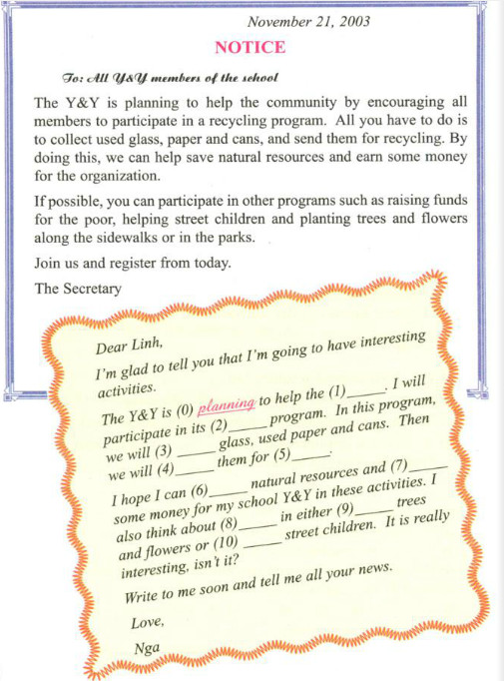
Suggested answer:
Dear Linh,
I'm glad to tell you that I'm going to have interesting activities.
The Y&Y is (0) planning to help the (1) community. I will participate in its (2) recycling program. In this program, I will (3) collect glass, used paper cans. Then we will (4) send them for (5) recycling.
I hope I can (6) save natural resources and (7) earn some money for my school Y&Y in these activities. I also think about (8) participating in either (9) planting trees and flowers or (10) helping street children. It is really interesting, isn’t it?
Write to me soon and tell me all your news.
Love,
Nga
Task 2. Read the dialogue between Hoa and her aunt. Then write Hoa’s letter to her parents telling what she is going to do.
(Hãy đọc hội thoại giữa Hoa và dì của bạn ấy rồi giúp Hoa viết thư gửi ba mẹ bạn ấy nói về việc bạn ấy đang làm.)
Aunt: Hoa, you look very happy today. Anything interesting at school?
Hoa: Yes, Aunt. I’m going to join the Y&Y Green Group.
Aunt: Really? What will you do?
Hoa: We are having an environment month.
And, we’re going to clean the banks of the lakes on weekends.
Aunt: Will you do anything else?
Hoa: Oh yes. We’re going to plant trees and flowers in the school garden and water them every afternoon after class.
Aunt: That sounds excellent.
Hoa: Yes, it is. And, we’re planting young trees and plants to sell to some schools. We hope to give more green color to the city and earn some money for our school Y&Y.
Aunt: You’re really great, Hoa!
Lời giải chi tiết:
Dear Mom and Dad,
I'm happy to tell you that I'll be able to join in the Green Group of my school.
The Green Group is holding an environment month. And there will be a lot of interesting activities to do in this program. We will clean the lakes' banks on the weekends, and plant trees and flowers in the school garden and water them every afternoon after class. In addition, we are planting young trees and plants to sell to other schools.
I hope that we can give more green color to the city and earn some money for school Y&Y. The program is really interesting, isn’t it?
I'll write to you and tell you more about group activities later. I'm OK and still work very hard. Aunt Lien is very pleased with me.
I hope you both are well.
With love,
Hoa

